Rudford and Highleadon Parish Council
EXTRA ORDINARY MEETING OF THE COUNCIL
HELD AT 7.30PM ON 4TH JULY 2022
IN THE VILLAGE HALL
Welcome and introductions
Attendance recorded as Parish Councillors Bob Wolfson, Mark Deane Sten Salisbury, Amanda Bye, Ian Turner, Robert Heigham, Stephen Harper, District Councillor Phillip Burford & 2 members of the public
Apologies for absence recorded from County Councillor Philip Robinson
District Councillor Brian Lewis did not attend
Declaration of Interest for matters on the agenda were invited
Public Participation was invited by Chair of meeting-
Report from County Councillor Philip Robinson -cfwd
Report from District Councillors Philip Burford / Brian Lewis-cfwd
Minutes of the previous Parish Council Meeting held on 23rd May 2022 approved
Chair of Council provided update from neighbouring parish/town council meetings held since last meeting of Rudford and Highleadon Parish Council
Local plan & housing policy – no updates from Parishes. District Councillor Burford gave general updates
4 local parish councils have met with FDDC planning officers regarding current/potential Solar Panel applications
Planning matters considered
P0271/22/FUL - Land to the South of Murrells End Farm, Murrells End, Hartpury, Gloucester. Installation and operation a of a renewable energy generating station comprising ground-mounted photovoltaic solar arrays together with inverter units, substation, site access, internal access tracks, security measures, access gates, other ancillary infrastructure and landscaping and biodiversity enhancements.

Council agreed to object –
The Parish Council objects to the proposal on the grounds that the impacts on the wider landscape, character, ecology, drainage, transport/access and heritage assets are not acceptable, especially in the light of other applications locally.

Link to submit – note no document upload- will need to be sent as document to Suzanne.Hares@fdean.gov.uk to be submitted 29th July 2022

P0271/22/FUL | Installation and operation a of a renewable energy generating station comprising ground-mounted photovoltaic solar arrays together with inverter units, substation, site access, internal access tracks, security measures, access gates, other ancillary infrastructure and landscaping and biodiversity enhancements. | Land To The South Of Murrells End Farm Murrells End Hartpury Gloucester GL19 3DF (fdean.gov.uk)

Council considered the landscape reports received on Moat Farm, Taynton and Laynes Wood, Highleadon.(as distributed)
It was agreed that Cllr Wolfson would to attend FDDC planning committee meeting to highlight the accumulation of applications
Council agreed to defer the accepting and signing the Deed of Gift (as distributed) from
JBM SOLAR PROJECTS 21 LIMITED to RUDFORD AND HIGHLEADON PARISH COUNCIL,
To provide funding for the resurfacing of footpath (GRU14) within the Bluebell Woods
in Rudford, providing year -round access for local residents
and to authorise Chair of Council (Cllr Wolfson) to sign the document on behalf of the Council
Any other business for information sharing purposes only

Maisemore application on next agenda Land South Of Maisemore Maisemore Gloucester Gloucestershire GL2 8HH 22/00397/FUL
Date of next meeting 25th July 2022

RESPONSE TO PLANNING APPLICATION P0271/22/FUL

Land to the South of Murrells End Farm, Murrells End, Hartpury, Gloucester.

Installation and operation a of a renewable energy generating station comprising ground-
mounted photovoltaic solar arrays together with inverter units, substation, site access, internal access tracks, security measures, access gates, other ancillary infrastructure and landscaping and biodiversity enhancements.

Before responding, the Council must draw attention to the extreme length and complexity of the application and associated documents, which require several hundred pages of reading, much of it of a technical nature. Given that the applicant chose not to hold a public meeting nor to make contact with the Parish Council to offer to attend a meeting and answer any questions, a significant barrier has been erected by the applicant in preventing responses from the informed lay Councillor. This concern applies especially to the very important 59 page report on landscape impact that forms a part of the Environmental Impact Assessment

The Council objects to this application for the following reasons:

- Impact on the landscape

In its application, Elgin Energy draws attention to UK Planning Policy as follows:

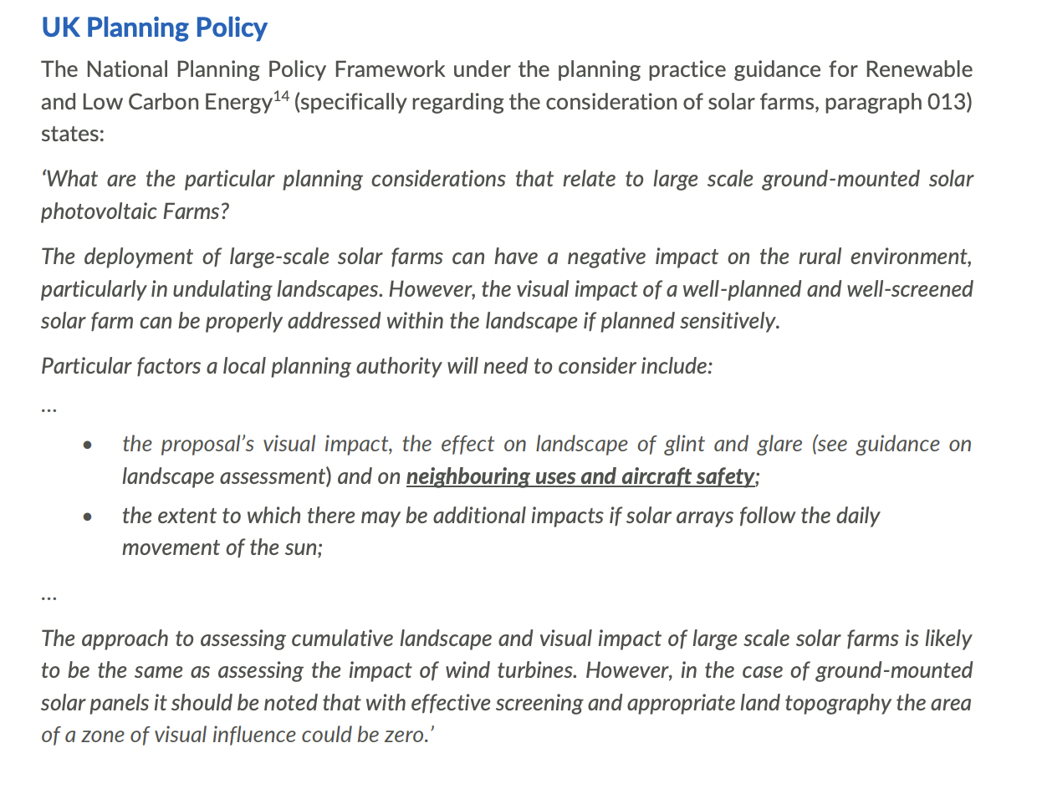

The key elements of this framework in relation to this application are: ‘The development of large-scale solar farms can have a negative impact on the rural environment, particularly in undulating landscapes’ and the reference in the final paragraph to ‘appropriate land topography’. The siting of this proposed solar farm is on the down slope of undulating landscape, thereby making it highly visible from the south and west, from the properties identified by the applicant, from the B4215 travelling northwards, and from the national footpaths, the Wysis Way and the Three Choirs Way which share a route at this point.

The applicants’ Design and Access Statement states that ‘Landscape enhancement proposals are incorporated into the scheme design and are detailed in the LVIA and Landscape Proposal Plan. The landscaping scheme includes measures to avoid, reduce, or remedy significant adverse impacts to ensure a good fit within the landscape setting. It also includes measures that would reduce the visual prominence of the solar arrays in local views through new and enhanced field boundary screen planting.’

The chapter on Landscape in the Environmental Impact Assessment provides an extraordinarily detailed analysis of the criteria that might be applied to determine the impact on landscape. Council notes that within this, at paragraph 5.68, neither Rudford nor Highleadon are listed among the identified settlements closest to the development, despite Rudford being the closest of all.

It is difficult to comment on all of the assertions in this chapter, but some of them give the Council significant cause for concern. For example in the table on page 21 the report states that ‘Wysis Way promoted trial (sic) (links Offas Dyke to Thames Path) crosses the Study Area, passing within 3 km of the Proposed Development site in the vicinity of Rudford and Lassington. Wysis Way intersects with Three Choirs Way in some places.’ This is simply inaccurate – the Wysis Way passes within several hundred metres of the site, and does not ‘intersect’ with the Three Choirs Way – they share a route at this point.

In the same table, the applicant states that ‘Footpath GHA53 approaches the Proposed Development site from the river crossing at Rudford running adjacent to the Proposed Development site is likely to be moderately well used for recreation.’ How can this judgement be made without local consultation?

On page 23, the applicant states that ‘Fieldwork concluded the area is not wild or tranquil.’ This is an extraordinary judgement, which appears to be based on ‘adjacent motor sport’ – such motor sport takes place very occasionally in Maisemore, several miles from Rudford – and the presence of pylons. Residents of Rudford certainly regard the area as at least ‘tranquil’ if not ‘wild’.

In its consideration of the value of the landscape, the applicant makes only passing reference to the river Leadon (‘riparian vegetation’). Local people regard the Leadon, together with the fish, birds and animals that live in, on and around it, and the walks beside it, with considerable fondness and Council is therefore surprised that the applicant has made no reference to it in its consideration of the value of the landscape. Further, no reference is made to the fact that the Wysis Way follows the route of the Hereford to Gloucester canal and subsequent railway line. Both of these were of considerable significance to the neighbourhood, and to the local history of the parish.

If this is the level of accuracy and local knowledge that the applicant has, Council questions the veracity of much else in the report.

Council does not agree with the conclusions of the applicant in paragraph 5.136 ‘The Severn Vale is undesignated countryside, attractive but typical of this part of Gloucestershire. Landscape value is assessed as Medium for this LCA. Sensitivity to development is a combination of landscape value and susceptibility. Given the low-lying nature of solar development, as opposed to other renewable energy types such a wind farms it is considered that LCA 6b has a Low to Medium landscape sensitivity to this type of development overall.’ 150 000 solar panels installed to a height of 3 metres do not, in the view of the Council, constitute a low to medium impact on the landscape. Further, Council takes the view that the applicant has underplayed the impact of the development in its conclusions at paragraphs 5.243 to 5.253 of the Environmental Impact Assessment.

- The semi-industrial nature of the site in a rural context.

The applicant describes its proposal to install 3.2m high panels – research indicates there would be around 150,000 of these - 2.4m high security fencing around the perimeter of the solar farm – presumably a distance of some 4 miles – with an unspecified number of CCTV cameras on 3 metre poles, 24 inverter stations of 6.93m x 2.43m x 3.07m at an intended elevation of 3.57m, a substation and four storage units of unspecified size.

The proposed solar farm is therefore planned to cover an area the size of an eighteen hole golf course, most of which will be highly visible, with what must be described as a semi-industrial enterprise. The applicant makes reference to mitigating the visual impact of the site by screening but refers to this as being ‘when fully grown’; given that the site will only operate for 40 years, it might be that such screening is only fully grown for half of its lifetime.

- Proximity to heritage assets

The proposed site is within approximately 300 metres of St Mary’s Church, Rudford, a Grade I listed building. Neighbouring it are three other listed buildings – the School Room next to the Church, Ingleside Farmhouse and Mill Cottage. The proposal will affect the setting of these heritage assets and impact on visitors to them. The Planning Authority has previously refused planning applications that impact upon these assets.

The 24 page chapter on heritage assets in the Environmental Impact Statement describes the impact of the solar farm on these assets as ‘minor’ or ‘negligible’. This is achieved by applying the applicant’s chosen criteria. The Council takes a rather different view; members of the public walking from Highnam to visit the historic Church at Rudford will clearly have the solar farm in their view for much of their journey. It will no longer be a historic building sitting in a rural environment.

- Effects on Public Rights of Way

The development will be highly visible from the Wysis Way and Three Choirs Way, national footpaths that share a route to the west of the river Leadon and are shown as A on the map below.

It will also impact on the footpath from Rudford to Hartpury identified as B on the map below. This is a popular route with local walkers, and is part of a featured walk on the Parish Council’s website. It is, in the Council’s view, rather more than ‘moderately well-used for recreation’. The Council assumes that if the application is approved, walkers on this route will walk alongside the 2.4m perimeter fencing, CCTV mounted on poles and many panels. The applicant has made no reference to mitigations for this.

This would also apply to the bridleway and footpath labelled C on the map below, which lie in Hartpury Parish.

In these respects, therefore, the application has a significant impact on the public interest.

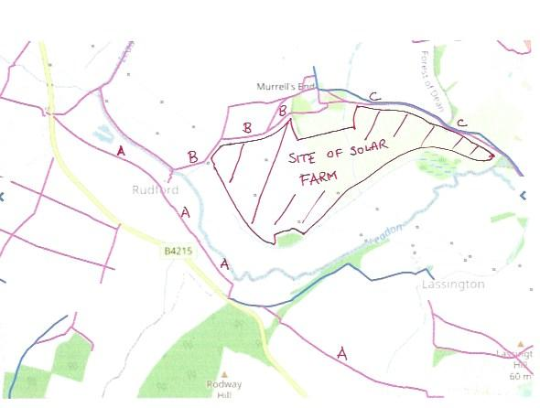

- Removal of arable land

For many years, the farmland on which the solar farm will be built has been used for arable farming. While the applicant makes reference to it remaining available for grazing, it is questionable whether additional grazing is needed at the expense of arable land, especially in the medium to long-term economic interests of the country.

The agricultural land survey summarises the land classification as follows:
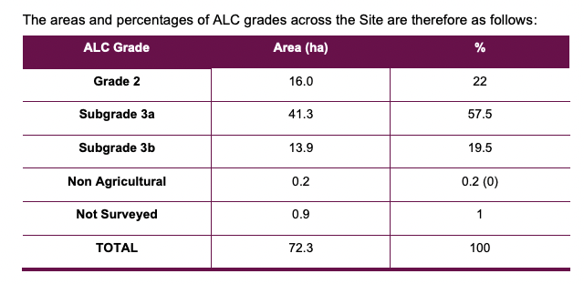
To put this in context, Grade 3 land is described as ‘Land with moderate limitations that affect the choice of crops, timing and type of cultivation, harvesting or the level of yield. Where more demanding crops are grown yields are generally lower or more variable than on land in grades 1 and 2.’

There is therefore no doubt that this proposal will remove a significant area of productive arable land that has been used as such for many years.

- Access during construction

The Council notes that the proposed route for construction traffic is from the A417 via the road to Hartpury College. This will be dependent on this route remaining open throughout the construction period and not being affected by flooding – a very regular occurrence in recent years.

The alternative route, and one that may be taken by contractors’ employees, whose movements cannot be controlled, is via the B4215 and then Park Road, Highleadon (the road linking Highleadon and Hartpury). This is a narrow road with several pinch points that is regularly the site of accidents, and includes the narrow Wedderburn Bridge which is also subject to flooding.

The Council has serious concerns about this route being used during the construction phase.

- Biodiversity

The applicant states in the Design and Access Statement that ‘Furthermore, the enhancement measures are in accordance with FDDC Allocations Plan Policy AP 7 ‘Biodiversity. The proposed measures in this application will secure the scheme’s +10% minimum units net biodiversity benefit. This will be set out in the Biodiversity Net Gain Assessment.’

The 31 page chapter on biodiversity in the Environmental Impact Statement provides enormous detail on that which it has chosen to survey. Council notes that the surveys were chiefly undertaken during January (other than the nesting birds survey in June); this may explain the absence of reference to deer, which have often been sited in the area and indeed on the fields designated to be the solar farm. Indeed, it seems odd that the applicants make no reference to deer, but are planning to build a fence to keep them out of the site. Council has been unable (as yet) to find the details of the ‘+10% net biodiversity benefit’ other than in references to the replanting of hedgerows and can only conclude at this stage that the applicant has provided yet another exhaustive report that tells us plenty about what it wants to, but omits important aspects.

There are some proposals regarding hedge planting, species rich grassland and wildflower planting embedded in paragraph 5.116 of the Landscape chapter of the Environmental Impact Assessment, but these are limited. Council notes especially the paucity of biodiversity proposals in this application compared with that for the Laynes Wood solar farm in the parish.

- The effects of the solar farm on the soil and landscape

The effect/s of the solar farm on soil quality appears uncertain. From various forums the conclusion is that the impact is low in terms of the majority of the operational life. The nutrient levels in the top layers of soil suffer from a phenomenon known as pattern leaching where nutrients under the "umbrella " of the panels remain undisturbed, but strips at the perimeter of each structure receive rainfall and runoff washing out nutrients. However, it is not dissimilar to an orchard in full leaf, and is easily remedied by redistribution by ploughing or similar once returned to agriculture.

There is a further concern relating to the impact of the construction and demolition methods on the sub-strata, and topsoil. The panels are supported on what are effectively steel mini-piles, either screwed, pushed or driven into the ground depending on the ground conditions. There is obviously a risk of the machinery causing compaction as it moves about. More of a concern could be the change in the structure of the soils caused by the steel support posts - either compaction by displacement as they go in, or creation of multiple voids as they come out. The final concern would be how the voids are filled on completion. It is unlikely that soil will be stockpiled on site for 40 years, so soil of a possibly lesser quality or with different characteristics could need importation at the conclusion of the life cycle of the solar farm.

The Council would urge the Planning Authority to require an assessment of the effects of minerals, including heavy metals, soil at, say, five yearly intervals, with the results made public.

- The lifetime of the proposed solar farm

Forty years as the projected lifetime of the equipment is a long time. This industry is still in its infancy and given government policy changes who knows what the life of this solar farm will actually be, it may become obsolete after say 15 years and will it then be left to moulder? Or, on the contrary, will the technology become such an established part of the future ‘energy landscape’ that the forty year lease is simply renewed?

Further, there is little or no indication of what happens at the end of the forty years. Are the panels themselves recyclable? What guarantees can be put in place that the land will be returned to its former state; there are strong indications that forty years of panels sitting on top of land leaves it in a worse state than at the start. (see above)

The Council would also urge the Planning Authority to ascertain what the life of the proposed panels will be, and whether they will require replacement during the 40 year period of the planned solar farm.

- The wider picture of solar farms in the area

This is one of three projects proposing to install a 49.9MW solar farm currently under consideration which will impact on the Parish or its closest neighbours, and there is already a solar farm a few miles away at Malswick. The map below shows these and especially emphasises the enormous size of the proposals in comparison to the existing farm.

Location | Acreage | Power to be generated
Moat Farm | 203 acres | 49.9 MW
Laynes Wood | 280 acres | 49.9 MW
Murrells Farm | 175 acres | 49.9 MW

These are very big solar farms. At the time of writing, each would be among the largest five solar farms in England. The current largest is on the former runway of RAF Lyneham and covers 213 acres generating 69.8 MW. Elgin Energy’s website reports that it has a farm in Northern Ireland generating 46MW, one in Norfolk generating 30 MW but almost all their others are below 10MW.

If all three are constructed, they would cover an area equivalent to more than six full size golf courses.
And to have three of them located within three miles of each other is a big ask of the local community.

Council therefore urges the Planning Authority to take a strategic overview of the situation and take a view of just how much of the rural landscape is to be taken up by solar farms. A few years ago, the (then) Minister’s spoke of government’s ‘desire to ‘see a lot, lot more’ but that as ‘we take solar to the next level, we must be thoughtful, sensitive to public opinion and mindful of the wider environmental and visual impacts’.

In this case, the applicant makes reference to other proposals in paragraph 5.233 of the Environmental Impact Assessment following an analysis of a number of applications, as follows: ‘There are five cumulative energy projects located within the Study Area as listed in Table 5.9 above. The cumulative developments identified together with the proposed Murrells End Solar Farm would not cause significant cumulative landscape or visual effects, either at the construction phase, or the operation and maintenance phase.’

Council disagrees most strongly with the view that such an extensive area of landscape given over to solar farms would be ‘sensitive to public opinion and mindful of the wider environmental and visual impacts’.

Conclusion

The District Council’s Local Plans response to this application as follows:

In principle, both national and local planning policies support this type of Renewable Energy schemes, however, the acceptability of this scale of scheme in this location will be highly dependent on the potential impact on the wider landscape, character, ecology, drainage, transport/access and heritage assets.

The Parish Council objects to the proposal on the grounds that the impacts on the wider landscape, character, ecology, drainage, transport/access and heritage assets are not acceptable, especially in the light of other applications locally.

