Rudford and Highleadon Parish Council
Draft minutes for the meeting of the above Parish Council
Which took place at 7.30pm on 27 November 2023 at the Village Hall

 | Welcome and introductions
Council agreed co-option of Parish Councillor Jill Deane (one of 2 vacancies).
Meeting was paused for signing of acceptance of office form. Council noted one Vacancy to be filled by co-option remains.
 | Council recorded attendance as Parish Councillors Bob Wolfson, Mark Deane, Ian Turner, Robert Heigham, Leon Jahae, County Councillor Philip Robinson, District Councillor Phillip Burford
Apologies for absence & acceptance of reasons for absences -none received.
District Councillor Clayton Williams did not attend
Council invited Declarations of Interest related to items in the agenda.
Item 10: Canal trust –Parish Councillors Ian Turner and Robert Heigham

 | Council approved the draft minutes of the meeting held on 25 September 2023.
 | Public Session - none at this point
Council received County Councillor verbal report
- Transport/bus funding
- Pothole repair funding
- “fixed my street” reporting portal
- Grit store update- formal agreement to be sent to Council to be considered – immediate response from Parish Council was that
the title of the report was not accurate
Question of banksman and highway management
Question of toilet facilities for operatives who are on site all day
No mention of CC representative attending the site on operational days
Who will be the named person in charge of site
Telephone number of said person
Weekend working is still contentious
The statement offers nothing new and does not show how the CC will remedy the situation
Question on how to respond to outcome of formal Stage 2 complaint and public question at the CC cabinet

Highways and footpath issues:
- Buttermilk Lane grit store: Council discussed the response to its Stage 2 complaint and determined its next course/s of action.
- Accidents at The Mounts corner: Council received update from County Council regarding Speed limits - there is no prospect of changing speed limits on the B4215, at Upleadon Road and Park Road. Changing speed limits is an expensive process (£15 000) because it requires a Traffic Regulation Order and therefore legal costs, so they will only take forward those cases that clearly meet the (fairly demanding) criteria.
Police data does not identify this as especially dangerous, partly because most of the accidents have been single vehicle. CC will get the signage cleared and replaced where necessary (there is a missing chevron sign). Council discussed the possibility of moving the VAS from north of Church Lane to a point further south, and CC will come back to PC on that. Council agreed that it was a good idea and likely to be more effective than where it is, but where to put it and how to access post to be further discussed.
- Woodside Cottages: Council received update on impending remedial work. The CC continues to think the solution lies in jetting across the fields but met serious opposition from the landowner. Owners from affected properties are going to try to persuade him, but in the meantime CC will look again at more clearing of the ditches on the eastern side of the road as a remedy.
- Railings replacement at Wedderburn Bridge. The work is now scheduled –
- Junction of B4215 and Upleadon Road, access from Church Lane to B4215 northwards and to bus stop. The 'Cobbled' junction from B4215 southbound into Upleadon Road – CC feel that this is like this to provide extra protection and avoid the kerb being damaged, and CC has no intention of changing it.
- Exit from Church Lane on to B4215 turning right - CC accepts this is very dangerous. The County Council does not approve of mirrors as safety devices. There appears to be no immediate solution
- Highleadon Green: Council noted the clarification of ownership and management issues – see note attached
- Vehicle Activated Sign: Council discussed its management and noted that data is available and can be analysed to provide information to other agencies. Councillors were invited to consider the future management

Planning matters: (members of the public were invited to speak at this point)

- Planning application for a holiday cottage at Rectory Fields, Church Lane P1290/23/FUL -Change of use of agricultural building to form a single unit of holiday accommodation, including improvement of the existing driveway and access. (deadline 7th December)
Council agreed to object on the following grounds
- If permitted, it would set a precedent that allowed the development of a property that has been improved without planning permission to the point where conversion was then permitted.
- The proposed access along 800 metres of the Three Choirs Way and the Wysis Way, which follow the route of the Hereford and Gloucestershire Canal, would cause significant damage to a regional and national asset.
- The proposed property is sufficiently close to the river Leadon to be at serious risk of flooding. The adjacent properties were flooded in both 2007 and 2020, and the applicant’s argument that it is in a ‘one in a hundred years’ risk is not borne out by events.
- There is no evidence of demand for additional holiday accommodation.
- Proximity to other buildings including heritage assets
- Outside nearest settlement boundary and is not sustainable
- Habitat of Bat colony noted
- Chair to provide background information
- Environmental agency/enforcement officer current issues noted
- Historical enforcement issues at the above site, involving 3 local authorities/agencies was also noted and discussed
- Enforcement issues at New Bliss Business Centre: Council noted update from the Local Government Ombudsman – no formal report yet received
Further concerns including multiple diggers working and importing materials via sheeted lorries to be reported to enforcement
- Murrell’s End Solar Farm: Council agreed its response to the Planning Inspector regarding the appeal against the refusal of planning permission (as distributed via draft) including final statement The Parish Council urges the Inspector to reject this appeal. To allow it will effectively negate Government guidance on Best and Most Versatile land, setting a precedent that will be exploited. Further, it will lead to the imposition of a semi-industrial facility on the rural landscape, close by two other similar but less impactful solar farms. (Members of the public encouraged to attend appeal)

- Laynes Wood Solar Farm: Council noted that planning permission has been granted and Council agreed its next steps in relation to community benefit grant. A meeting was held with Parish Councillors and other interested parties (Severn Wye Energy and JMB Solar) on 24th November 2023 to begin discussion on the Community Benefit Fund- cfwd to future agenda
- GR14 footpath improvements (Bluebell walk) - PROW officer has been contacted and the CC are planning to improve 200 yards and the PC will have a shorter length to fund.

Council approved the financial reports and expenditure including payment
- District Council for election costs in May 2023 £211.80
- Salary standing order reduced to £158.00 pm asap (includes wfh allowance)
- HMRC (oct) £88.00
- Clerk expenses to be contra against salary s/o £12.20

Council approved other Financial matters:
- Council agreed the precept/ budget for 2024-25 £4630
- Council approved the recommendation of NALC to increase salary of Clerk by £1 per hour backdated to 1/4/23.
- Council noted potential impending changes to regulations regarding grants to Parochial Church Councils
- Council approved Iain Selkirk as auditor for 23/24
Council received District Councillor Burford report
- New CEO
- Joint working (Publica)
Council considered feedback from meeting with JBM Solar and Severn Wye Energy – noted
Clerk to explores powers that could be used in this instance
 | Council noted model policy on biodiversity (attached) and to be considered on next agenda
 | Council confirmed the dates for meetings in 2024: January 22nd, March 25th Parish Assembly agreed for 22nd April 2024, AGM May 13th (2nd Monday), 22nd July, 23rd September, 25th November agreed by Council
17 | Minor Items Raised by Members for Future Agenda: -none
 | Close of meeting 21.22pm

Draft minutes of the meeting of the above Parish Council
held at 7.30pm on 25 September 2023 at the Village Hall

Welcome and introductions
Council recorded attendance as Parish Councillors Bob Wolfson, Ian Turner, Robert Heigham & District Councillor Clayton Williams and 2 members of the public
Parish Councillor Leon Jahae attended at 19.52
Apologies for absence & acceptance of reasons for absences recorded: Parish Councillor Mark Deane, County Councillor Philip Robinson, District Councillors Phillip Burford
Council invited Declarations of Interest related to items in the agenda. -none
Council noted the resignation of Councillor Harper
Clerk has published notice for potential election and will advise Council on the process
Council noted the response of the District Council to the Parish Council’s complaint in relation to this matter.
Council considered publicity drive for vacancy of Parish Councillor when outcome of “call for election”
Council approved the draft minutes of the meeting held on 24 July 2023.
Public comments were invited for 15 minutes at Chairman’s Discretion: none at this stage
Council noted there was no County Councillor report
Highways and footpath issues:
- Buttermilk Lane grit store: Council noted the response to its Stage 2 complaint and determine next course/s of action -likely to be after 23rd October meeting with CC Robinson/Highways Manager
- Accidents at The Mounts corner: Council noted update from County Council
- Woodside Cottages: Council noted update on impending remedial work as work is being held up by landowner. Council agreed delegated authority to Clerk to correspond if necessary
- Other matters reported to the County Council: Council noted the following issues - railings replacement at Wedderburn Bridge, speed of vehicles on Park Road and Upleadon Road, potholes in Buttermilk Lane, junction of B4215 and Upleadon Road, access from Church Lane to B4215 northwards and to bus stop- Chair will follow up.
- Highleadon Green: overhanging trees at Camp Cottage (email correspondence)
PC to write to DC to confirm ownership of Common Land as the DC has intervened in previous situations. DC has responded to member of the public stating that the DC does not own Common land
Councillors considered if HLGA would be setting a precedent by undertaking tree work but it is known that HLGA has previously done work on the Common
Councillors are going to meet the residents to discuss the situation
Council agreed to write to DC to confirm ownership of Common Land
Council agreed to write to HLGA to clarify the responsibilities of the HLGA
Council agreed to consider a grant if requested
Planning matters:
- Enforcement issues at New Bliss Business Centre: Council noted the outcome of referral to Local Government Ombudsman on behalf of residents is that the LGO will investigate the matter
Resident gave an update on potential activities inside the Barn on the site. (meeting was adjourned for 5 minutes)
- Solar Farms in the area: Council received an update on planning applications relating to Moat Farm Newent (no news) and Laynes Wood Highleadon (anticipated to be considered in November)
- Aggregate company in Highleadon: Council noted that enforcement action has been taken.
Council invited Councillor Williams to submit a report
Update on planned Scrutiny committee into planning processes – noted delay
No other matters
Council approved the financial reports and expenditure as presented by Clerk

Finance: Council reviewed the budget for 2023-24 and agreed not to make any amendments at this
Noted that:
- Council has decided not to renew the service agreement with Swarco for the MVAS
- Council noted that they will not be charged for venue hire for 2023/24
- The Clerk has advised that NALC/GAPTC had recommended that clerks should be employed for no less than 5 hours per week- this has now been amended to 4 hours per week
Council noted that information regarding celebration of anniversary of D Day in June 2024 is being circulated as a potential community event
Council confirmed the dates for remaining meeting of 2023: November 27th (budget and precept)
Minor Items Raised by Members for Future Agenda:
None
Close of meeting at 20.16

Financial reports

RESERVES
RESERVES bfwd 1/4/22
General reserves |  | 1644
precept reserve |  | 1000
Earmarked tree reserves |  | 115
under spend/overspend at y/e 3/23 |  | 987
total reserves as per bank reconciliation AT 1/4/23 |  | 3746

payroll |  | cashbook | pata
gross |  | 1605.83 | 1544.27
tax |  | 396.60 | 396.6 | 0.00
net |  | 1209.23 | 1147.67 | 61.56 | 31/10/2023
expenses | May-23 | Jul-23 | sept |  | nov
wfh | 26 | 26 | s/o
printing | 3.2 | 3.2 | 3.2 |  | 3.2
year end | 5 |  | 0.41 | salary
mileage | 18 | 9 | 9 |  | 9
 | 52.2 | 38.2 | 12.61 |  | 12.2 to be paid as part of salary s/o

Bank reconciliations
01/04/2023 | OPENING BANK BALANCE | 3745.94
 | EXPENDITURE FOR PERIOD | -2733.37
 | INCOME FOR PERIOD | 4410.00
 | NET EXPENDITURE |  | 1676.63
 | BANK BALANCE | 5422.57
27/10/2023 | BAL PER S/M |  | 5510.57
 | hmrc oct | 88.00
 |  |  | 88.00
21/11/2023 | reconciled balance |  | 5422.57

Cash book to 21/11/23

DATE | PAYEE | TRANSACTIONS | CURRENT A/C BALANCE
01/04/2023 |  |  | 3745.94
21/04/2023 | precept | 4410.00 | 8155.94
21/04/2023 | hmrc | -44.00 | 8111.94
21/04/2023 | salary | -246.61 | 7865.33
21/05/2023 | hmrc | -44.20 | 7821.13
21/05/2023 | salary | -228.61 | 7592.52
21/05/2023 | gaptc | -75.83 | 7516.69
21/05/2023 | pata payroll | -103.20 | 7413.49
02/06/2023 | gallagher insurance | -509.30 | 6904.19
27/06/2023 | hmrc | -44.00 | 6860.19
27/06/2023 | salary | -202.61 | 6657.58
24/07/2023 | hmrc | -44.20 | 6613.38
17/07/2023 | hartpury university | 200.00 | 6813.38
24/07/2023 | signature 86 (sign) | -400.00 | 6413.38
24/07/2023 | I selkirk | -150.00 | 6263.38
02/08/2023 | gcc | 200.00 | 6463.38
29/08/2023 | b holder | -202.00 | 6261.38
04/09/2023 | hmrc | -44.20 | 6217.18
24/07/2023 | b holder | -214.61 | 6002.57
30/09/2023 | b holder | -202.00 | 5800.57
30/10/2023 | b holder | -202.00 | 5598.57
30/11/2023 |  | 0.00 | 5598.57
09/10/2023 | hmrc (sept) | -88.00 | 5510.57
31/10/2023 | hmrc oct | -88.00 | 5422.57

BUDGET Against actual | budget for 2023/24 | year to date 31/10/23 | BALANCE AVAILABLE TO SPEND | proposed 24/25
PRECEPT | 4410 | 4410 | 0 | 5225 | £4630 | 5%
vat refund |  | 0 | 0 |  | £4820 | 10%
insurance claim |  | 0 | 0
INCOME | 4410 | 4410 | 0 | 5225
EXPENSES
salary | 2700 | 1606 | 1094 | 3000 | rounding up plus potential 24/25 increase
HIRE OF VENUE | 120 | 0 | 120 | 120 | £15 pm x8 -remove
SUBSCRIPTION TO GAPTC | 80 | 76 | 4 | 80
TRAINING | 220 | 0 | 220 | 200 | new cllrs-remove
INSURANCE | 380 | 509 | -129 | 500
USE OF HOME/ mileage and stationery | 400 | 289 | 111 | 400 | £26 x 12+£9x6
TREES | 0 | 0 | 0
footpath | 100 | 0 | 100 | 100 | Earmark remove
DONATIONS S137 | 100 | 0 | 100 | 100 | d day remove
VAS costs | 210 | 0 | 210 | 210 | -remove
audit fees | 150 | 150 | 0 | 150
Neighbourhood D P | 0 |  | 0
election costs | 260 |  |  | 260 | uncontested /earmark -remove
ADMINISTRATION COSTS | 95 | 103 | -8 | 105 | pata
bus shelter and other highway projects |  | 0 | 0
PREDICTED SURPLUS | -405 |  | -405 |  | from reserves
EXPENDITURE TOTAL | 4410 | 2733 | 1417 | 5225
balance available | 0 | 1677 | 1417

The proposed budget is a starting point for Councillors to consider the priorities for the coming year.
The precept is set to meet the proposed expenditure
No account is taken of increased/decreased tax base
Expenditure is not increased by set inflation figure but is based on actual spends in 2023/24 except for salaries

RUDFORD AND HIGHLEADON PARISH COUNCIL

OWNERSHIP AND MANAGEMENT OF HIGHLEADON GREEN

NOVEMBER 2023

The letter below is the basis for the respective responsibilities regarding Highleadon Green.

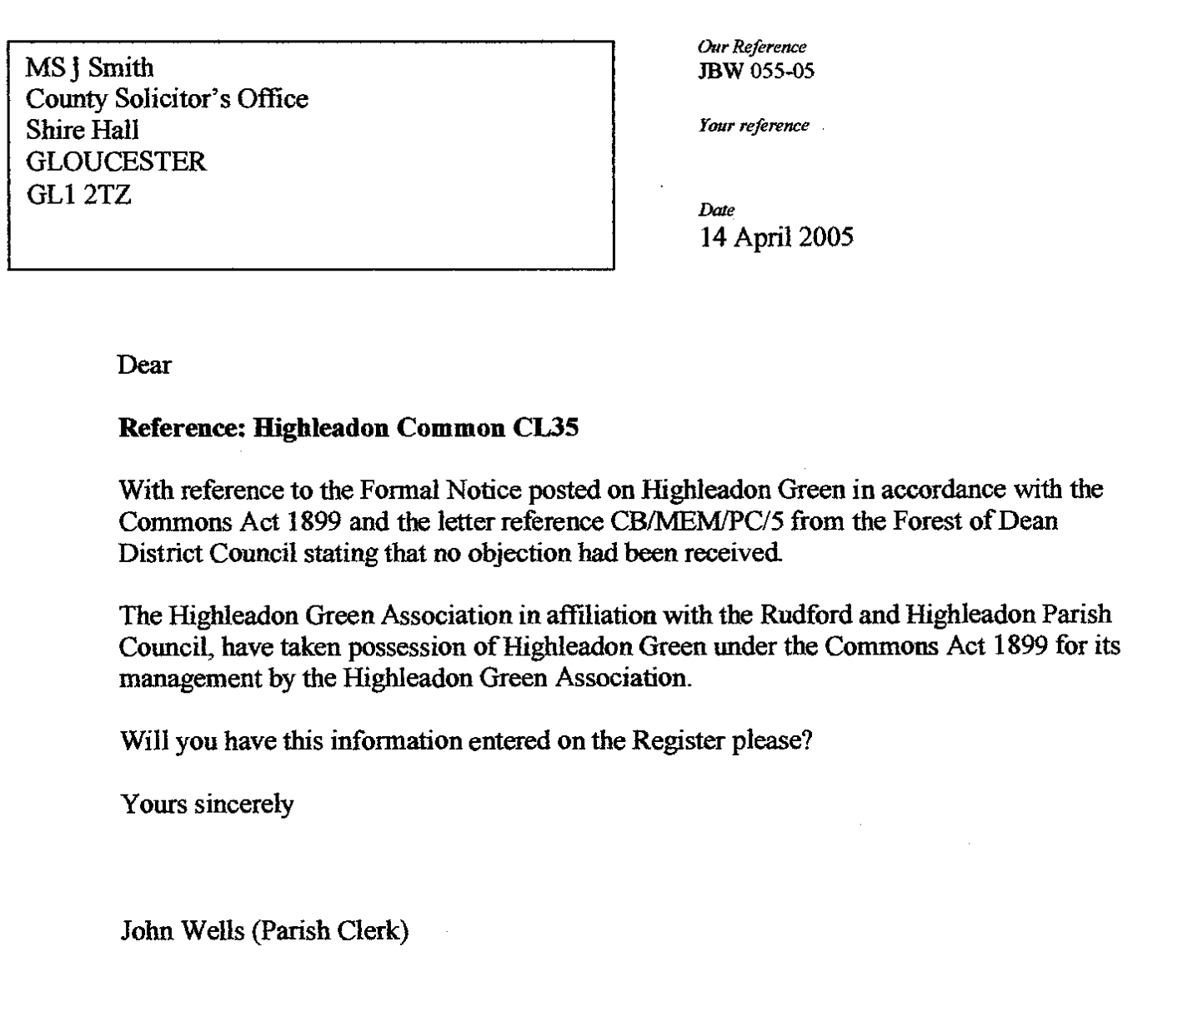

The District Council has recently clarified its understanding of its responsibilities as de jure owners as follows:
‘Pursuant to the decision issued by the Commons Commissioner dated 12 December 1985, Highleadon Common was ruled to have no owner. AS a result the protections of S9 of the Commons Registration Act apply and give powers to FODDC as the local authority in whose area the land is situated. As a result the Council has powers to may take such steps for the protection of the land against unlawful interference as could be taken by an owner in possession of the land, and may bring proceedings for any offence. This does not grant any ownership of the land or direct responsibility.
Under the Occupiers Liability Act 1984 a person is classed as an occupier if they owe the common duty of care referred to in section 2 of the Occupiers’ Liability Act 1957, in relation to the premises – This includes having control of that premises. It is this last point that brings a duty to the Council. However where this relates to Common Land s13 of Countryside and Rights of Way Act 2000 “reduces” the common duty of care to persons accessing the Common whereby an occupier owes NO duty to any person exercising their access rights in respect of a risk from: Any natural feature of the landscape (including any tree, shrub or plant), Any river, stream, ditch or pond, People passing over, under or through any wall, fence or gate, except by proper use of a gate or stile. Essentially persons accessing the Common are not classed as visitors.
This “reduction” of liability does not extend to accidents as a result of activities carried out on the Common, such as maintenance or from man-made structures such as stiles where these are faulty or unsafe. The Council is likely liable where we have caused a risk or been reckless to causing a risk . These liabilities should be managed by risk assessment and works to reduce / remove the hazard.’

