Rudford and Highleadon Parish Council
Agenda/summons for the meeting of the above Parish Council
to take place at 7.30pm on 27 November 2023 at the Village Hall

Welcome and introductions
Council to consider and agree co-option of Parish Councillor (one of 2 vacancies). Jill Deane has confirmed her eligibility.
Meeting will be paused for signing of acceptance of office form. One Vacancy to be filled by co-option remains, and Councillors will consider how it might be filled.
To record attendance (anticipated as) Parish Councillors Bob Wolfson, Mark Deane, Ian Turner, Robert Heigham, Leon Jahae, County Councillor Philip Robinson, District Councillors Phillip Burford and Clayton Williams
Apologies for absence & acceptance of reasons for absences to be recorded
To receive Declarations of Interest related to items in the agenda.

To approve the draft minutes of the meeting held on 25 September 2023.
Public Session - 15 minutes at Chairman’s Discretion: members of the public may ask questions or comments on matters on the agenda

Council to receive County Councillor report
Highways and footpath issues:
- Buttermilk Lane grit store: Council to discuss the response to its Stage 2 complaint and determine next course/s of action. (It is anticipated that the response will be received before the meeting)
- Accidents at The Mounts corner: Council to receive update from County Council
- Woodside Cottages: Council to receive update on impending remedial work
- Other matters reported to the County Council: Council to note the following issues - railings replacement at Wedderburn Bridge, speed of vehicles on Park Road and Upleadon Road, potholes in Buttermilk Lane, junction of B4215 and Upleadon Road, access from Church Lane to B4215 northwards and to bus stop.
- Highleadon Green: Council to note the clarification of ownership and management issues – see note below
- Vehicle Activated Sign: Council to discuss its management
Planning matters:
- Planning application for a holiday cottage at Rectory Fields, Church Lane (P1290): Council to consider its response to this application
- Enforcement issues at New Bliss Business Centre: Council to note that the Local Government Ombudsman has yet to report on his investigation.
- Laynes Wood Solar Farm: Council to note that planning permission has been granted and to determine next steps in relation to community benefit grant
- Murrell’s End Solar Farm: Council to determine its response to the Planning Inspector regarding the appeal against the refusal of planning permission.
Council to approve the financial reports and expenditure as presented by Clerk, including payment to District Council for election costs in May 2023 £211.80
Salary standing order to be reduced to £158.00 pm asap (includes wfh allowance)
HMRC (oct) £88.00
Clerk expenses to be contra against salary s/o £12.20

Finance:
- Council to consider the budget for 2024-25 and determine the precept for 2024-25 (papers attached)
- Council to approve the recommendation of NALC to increase salary of Clerk by £1 per hour.
- Council to note impending changes to regulations regarding grants to Parochial Church Councils
- Council to approve Iain Selkirk as auditor for 23/24
Council to receive District Councillor report
Council to consider feedback from meeting with JBM Solar and Severn Wye Energy
Council to note model policy on biodiversity (attached) and consider future action/s.
To confirm the dates for meetings in 2024: January 22nd , March 25th (may also be Parish Assembly) May 13th (2nd Monday) 28th or 29th May (4th Tuesday/Wednesday) to be agreed by Council
Minor Items Raised by Members for Future Agenda:
Close of meeting

Draft minutes of the meeting of the above Parish Council
held at 7.30pm on 25 September 2023 at the Village Hall

Welcome and introductions
Council recorded attendance as Parish Councillors Bob Wolfson, Ian Turner, Robert Heigham & District Councillor Clayton Williams and 2 members of the public
Parish Councillor Leon Jahae attended at 19.52
Apologies for absence & acceptance of reasons for absences recorded: Parish Councillor Mark Deane, County Councillor Philip Robinson, District Councillors Phillip Burford
Council invited Declarations of Interest related to items in the agenda. -none
Council noted the resignation of Councillor Harper
Clerk has published notice for potential election and will advise Council on the process
Council noted the response of the District Council to the Parish Council’s complaint in relation to this matter.
Council considered publicity drive for vacancy of Parish Councillor when outcome of “call for election”
Council approved the draft minutes of the meeting held on 24 July 2023.
Public comments were invited for 15 minutes at Chairman’s Discretion: none at this stage
Council noted there was no County Councillor report
Highways and footpath issues:
- Buttermilk Lane grit store: Council noted the response to its Stage 2 complaint and determine next course/s of action -likely to be after 23rd October meeting with CC Robinson/Highways Manager
- Accidents at The Mounts corner: Council noted update from County Council
- Woodside Cottages: Council noted update on impending remedial work as work is being held up by landowner. Council agreed delegated authority to Clerk to correspond if necessary
- Other matters reported to the County Council: Council noted the following issues - railings replacement at Wedderburn Bridge, speed of vehicles on Park Road and Upleadon Road, potholes in Buttermilk Lane, junction of B4215 and Upleadon Road, access from Church Lane to B4215 northwards and to bus stop- Chair will follow up.
- Highleadon Green: overhanging trees at Camp Cottage (email correspondence)
PC to write to DC to confirm ownership of Common Land as the DC has intervened in previous situations. DC has responded to member of the public stating that the DC does not own Common land
Councillors considered if HLGA would be setting a precedent by undertaking tree work but it is known that HLGA has previously done work on the Common
Councillors are going to meet the residents to discuss the situation
Council agreed to write to DC to confirm ownership of Common Land
Council agreed to write to HLGA to clarify the responsibilities of the HLGA
Council agreed to consider a grant if requested
Planning matters:
- Enforcement issues at New Bliss Business Centre: Council noted the outcome of referral to Local Government Ombudsman on behalf of residents is that the LGO will investigate the matter
Resident gave an update on potential activities inside the Barn on the site. (meeting was adjourned for 5 minutes)
- Solar Farms in the area: Council received an update on planning applications relating to Moat Farm Newent (no news) and Laynes Wood Highleadon (anticipated to be considered in November)
- Aggregate company in Highleadon: Council noted that enforcement action has been taken.
Council invited Councillor Williams to submit a report
Update on planned Scrutiny committee into planning processes – noted delay
No other matters
Council approved the financial reports and expenditure as presented by Clerk

Finance: Council reviewed the budget for 2023-24 and agreed not to make any amendments at this
Noted that:
- Council has decided not to renew the service agreement with Swarco for the MVAS
- Council noted that they will not be charged for venue hire for 2023/24
- The Clerk has advised that NALC/GAPTC had recommended that clerks should be employed for no less than 5 hours per week- this has now been amended to 4 hours per week
Council noted that information regarding celebration of anniversary of D Day in June 2024 is being circulated as a potential community event
Council confirmed the dates for remaining meeting of 2023: November 27th (budget and precept)
Minor Items Raised by Members for Future Agenda:
None
Close of meeting at 20.16

Financial reports

RESERVES
RESERVES bfwd 1/4/22
General reserves |  | 1644
precept reserve |  | 1000
Earmarked tree reserves |  | 115
under spend/overspend at y/e 3/23 |  | 987
total reserves as per bank reconciliation AT 1/4/23 |  | 3746

payroll |  | cashbook | pata
gross |  | 1605.83 | 1544.27
tax |  | 396.60 | 396.6 | 0.00
net |  | 1209.23 | 1147.67 | 61.56 | 31/10/2023
expenses | May-23 | Jul-23 | sept |  | nov
wfh | 26 | 26 | s/o
printing | 3.2 | 3.2 | 3.2 |  | 3.2
year end | 5 |  | 0.41 | salary
mileage | 18 | 9 | 9 |  | 9
 | 52.2 | 38.2 | 12.61 |  | 12.2 to be paid as part of salary s/o

Bank reconciliations
01/04/2023 | OPENING BANK BALANCE | 3745.94
 | EXPENDITURE FOR PERIOD | -2733.37
 | INCOME FOR PERIOD | 4410.00
 | NET EXPENDITURE |  | 1676.63
 | BANK BALANCE | 5422.57
27/10/2023 | BAL PER S/M |  | 5510.57
 | hmrc oct | 88.00
 |  |  | 88.00
21/11/2023 | reconciled balance |  | 5422.57

Cash book to 21/11/23

DATE | PAYEE | TRANSACTIONS | CURRENT A/C BALANCE
01/04/2023 |  |  | 3745.94
21/04/2023 | precept | 4410.00 | 8155.94
21/04/2023 | hmrc | -44.00 | 8111.94
21/04/2023 | salary | -246.61 | 7865.33
21/05/2023 | hmrc | -44.20 | 7821.13
21/05/2023 | salary | -228.61 | 7592.52
21/05/2023 | gaptc | -75.83 | 7516.69
21/05/2023 | pata payroll | -103.20 | 7413.49
02/06/2023 | gallagher insurance | -509.30 | 6904.19
27/06/2023 | hmrc | -44.00 | 6860.19
27/06/2023 | salary | -202.61 | 6657.58
24/07/2023 | hmrc | -44.20 | 6613.38
17/07/2023 | hartpury university | 200.00 | 6813.38
24/07/2023 | signature 86 (sign) | -400.00 | 6413.38
24/07/2023 | I selkirk | -150.00 | 6263.38
02/08/2023 | gcc | 200.00 | 6463.38
29/08/2023 | b holder | -202.00 | 6261.38
04/09/2023 | hmrc | -44.20 | 6217.18
24/07/2023 | b holder | -214.61 | 6002.57
30/09/2023 | b holder | -202.00 | 5800.57
30/10/2023 | b holder | -202.00 | 5598.57
30/11/2023 |  | 0.00 | 5598.57
09/10/2023 | hmrc (sept) | -88.00 | 5510.57
31/10/2023 | hmrc oct | -88.00 | 5422.57

BUDGET Against actual | budget for 2023/24 | year to date 31/10/23 | BALANCE AVAILABLE TO SPEND | proposed 24/25
PRECEPT | 4410 | 4410 | 0 | 5225
vat refund |  | 0 | 0
insurance claim |  | 0 | 0
INCOME | 4410 | 4410 | 0 | 5225
EXPENSES
salary | 2700 | 1606 | 1094 | 3000 | roundng up plus potential 24/25 increase
HIRE OF VENUE | 120 | 0 | 120 | 120 | £15 pm x8
SUBSCRIPTION TO GAPTC | 80 | 76 | 4 | 80
TRAINING | 220 | 0 | 220 | 200 | new cllrs
INSURANCE | 380 | 509 | -129 | 500
USE OF HOME/ mileage and stationery | 400 | 289 | 111 | 400 | £26 x 12+£9x6
TREES | 0 | 0 | 0
footpath | 100 | 0 | 100 | 100 | earmark
DONATIONS S137 | 100 | 0 | 100 | 100 | d day
VAS costs | 210 | 0 | 210 | 210
audit fees | 150 | 150 | 0 | 150
Neighbourhood D P | 0 |  | 0
election costs | 260 |  |  | 260 | uncontested /earmark
ADMINISTRATION COSTS | 95 | 103 | -8 | 105 | pata
bus shelter and other highway projects |  | 0 | 0
PREDICTED SURPLUS | -405 |  | -405 |  | from reserves
EXPENDITURE TOTAL | 4410 | 2733 | 1417 | 5225
balance available | 0 | 1677 | 1417

The proposed budget is a starting point for Councillors to consider the priorities for the coming year.
The precept is set to meet the proposed expenditure
No account is taken of increased/decreased tax base
Expenditure is not increased by set inflation figure but is based on actual spends in 2023/24 except for salaries

RUDFORD AND HIGHLEADON PARISH COUNCIL

OWNERSHIP AND MANAGEMENT OF HIGHLEADON GREEN

NOVEMBER 2023

The letter below is the basis for the respective responsibilities regarding Highleadon Green.

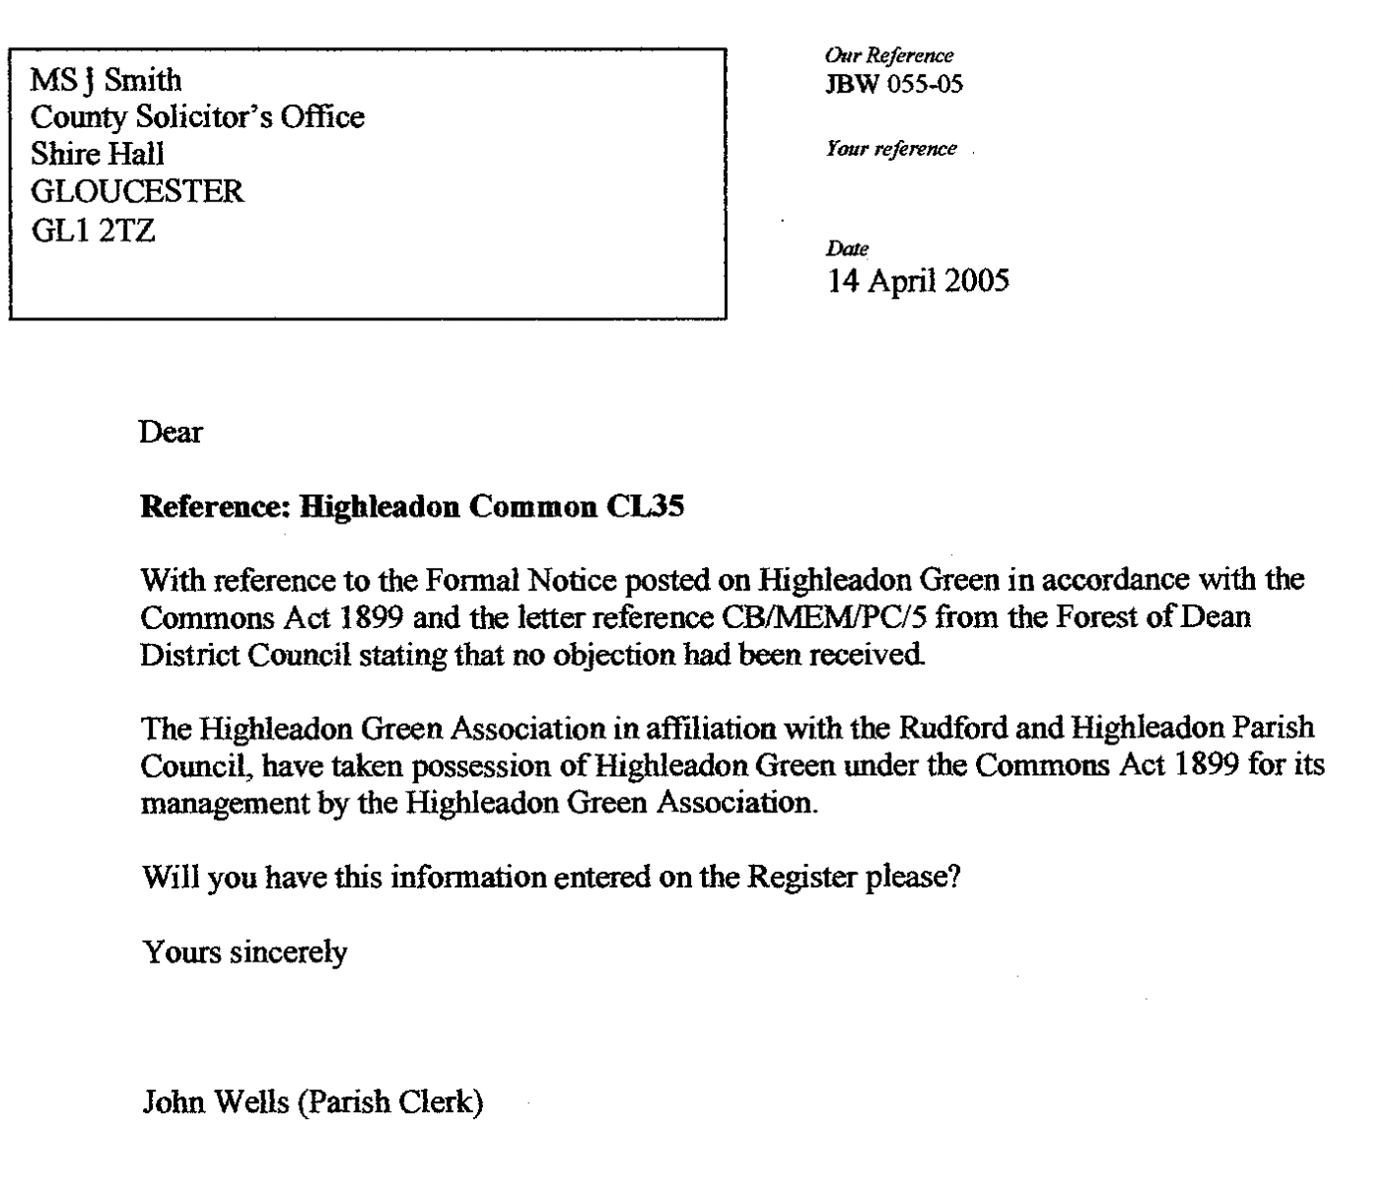

The District Council has recently clarified its understanding of its responsibilities as de jure owners as follows:
‘Pursuant to the decision issued by the Commons Commissioner dated 12 December 1985, Highleadon Common was ruled to have no owner. AS a result the protections of S9 of the Commons Registration Act apply and give powers to FODDC as the local authority in whose area the land is situated. As a result the Council has powers to may take such steps for the protection of the land against unlawful interference as could be taken by an owner in possession of the land, and may bring proceedings for any offence. This does not grant any ownership of the land or direct responsibility.
Under the Occupiers Liability Act 1984 a person is classed as an occupier if they owe the common duty of care referred to in section 2 of the Occupiers’ Liability Act 1957, in relation to the premises – This includes having control of that premises. It is this last point that brings a duty to the Council. However where this relates to Common Land s13 of Countryside and Rights of Way Act 2000 “reduces” the common duty of care to persons accessing the Common whereby an occupier owes NO duty to any person exercising their access rights in respect of a risk from: Any natural feature of the landscape (including any tree, shrub or plant), Any river, stream, ditch or pond, People passing over, under or through any wall, fence or gate, except by proper use of a gate or stile. Essentially persons accessing the Common are not classed as visitors.
This “reduction” of liability does not extend to accidents as a result of activities carried out on the Common, such as maintenance or from man-made structures such as stiles where these are faulty or unsafe. The Council is likely liable where we have caused a risk or been reckless to causing a risk . These liabilities should be managed by risk assessment and works to reduce / remove the hazard.’

