Rudford and Highleadon Parish Council
Agenda for the meeting of the above Parish Council
to take place at 7.30pm on 24 January 2022 at the Village Hall
Due to Covid restrictions, number of members of the public in the meeting may need to be restricted. Please wear face masks whilst inside the building

To note all present
Anticipated attendance Parish Councillors Bob Wolfson, Mark Deane, Sten Salisbury, Amanda Bye, Ian Turner, Robert Heigham, County Councillor Philip Robinson, District Councillors Phillip Burford and Brian Lewis
apologies for absence & acceptance of reasons for absences to be recorded
To determine whether to co-opt Steven Harper as a Parish Councillor to fill the vacancy created by the resignation of Councillor Perry-Gardiner (and if so, a short pause will allow for forms to be completed and Mr Harper will then be able to join the Council)
To receive Declarations of Interest related to items in the agenda.
Council to note that monitoring officer has now asked for new forms from all councillors unless done so in last 2 years
To approve the minutes of the meeting held on 22 November 2021.
Public Session - 15 minutes at Chairman’s Discretion. Where members of the public may ask questions or comments on matters on the agenda or other matters of interest in the Parish
Council to receive an update on actions to reduce risk of flooding and remaining actions (see chart below agenda).
Planning matters:
- Enforcement issues at New Bliss Business Centre
- Enforcement issues P0165 at Rectory Fields, Church Lane
- Alison House P1880/21/LD1: response of Planning Authority to Parish Council questions and further action/s
- Rose Cottage, Whitehall Lane P1991/21/FUL: to note that the Parish Council determined to make no comment
- Four Winds, Upleadon Road: construction of outbuilding. (see advice on outbuildings in gardens from FoDDC shown below this agenda)
- Pending consideration at this time: P0162 – Shooting Ground in Hartpury Parish
- Land for sale at Dark Barn: response of Planning Authority regarding access
- JBM Solar's proposals for Laynes Wood Solar Farm: timetable for planning application and potential community benefit contribution
Forest of Dean District Council Development Plan: Councillor Wolfson to report on the most recent Cross-Parish group
Highways issues:
a. Path to the bus stops at Highleadon Green: to confirm completion and financing of further drainage needed.
b. Footpath GR14 – Councillors to further consider making application to the Build Back Better Fund
c. Road sign at Orchard House, Park Road
Correspondence received as distributed by email to Councillors
a. Newent-Gloucester cycleway: request for support of the Parish Council for the proposed extension to the Newent cycle loop.
b. Correspondence from resident distributed by e-mail
c. Correspondence re Platinum Jubilee
Financial reports: Council to approve the financial reports and payments list as attached
Councillor Wolfson to report on meeting with representatives of St Mary’s Church, Rudford regarding financial support for the maintenance of the churchyard
Council to receive County Councillor reports
Council to receive District Councillor reports
To confirm the dates for the remainder of meetings in 2022: 28 March, 25 April (Parish Meeting), 23 May (Parish Council AGM), 25 July, 26 September, 28 November. All to be held at 7.30 at Rudford and Highleadon Village Hall.
Minor Items Raised by Members for Future Agenda:
Close of meeting

REDUCING FLOOD RISK IN RUDFORD
RUDFORD AND HIGHLEADON PARISH COUNCIL: FLOODING UPDATE JANUARY 2022
Area and risk/s | Actions required | Individual/s and organisations responsible | Update January 2022
1. B4215 between Trioscape and Keyway | Roadside drains inadequate for volume of water and/or grip cuts in verges blocked | GCC Highways | GCC has reported that this work has now been completed
2. Properties at river end of Church Lane | Flooding of river Leadon | Liaison between property owners and Environment Agency. | Property owner has done significant clearance work to the river, and protection work to the house.
3. Whitehall Lane: flooding of lane and ingress to barns south of Whitehall Lane | 1. Drains and kerbing on B4215  Drains have been surface cleared but need jetting. | GCC Highways | GCC has reported that this work has now been completed and drainage should be effective
 | 2. Culvert under the B4215 at Salcombe Farm needs enlarging or other approaches to reduce volume of water at crossing point | GCC Highways and Internal Drainage Board | Meeting with IDB has taken place and IDB will follow up possible clearing of ditch to south of B4215 with riparian owners
 | 3. Run-off from field exacerbated by Severn Trent Water works | STW | Field has been reinstated
4. Woodside Cottages | Flooding as a result of inadequate culvert | GCC Highways | GCC has cleared the ditch on the southbound side. IDB advise that the only solution is to widen the culvert under the road.
5. Buttermilk Lane and Old Road properties | Flooding in part from field behind houses but chiefly from: (1) run-off from Old Road (2) inadequacy of drainage under Buttermilk Lane and at sides of tip, exacerbated by (1) run-off of gravel from tip and (2) from the field as in 3.3 above | Ditch to rear of properties is well maintained.  GCC Highways to clear this  STW | This work has yet to be completed, and GCC has been further reminded of this  Field has now been reinstated
6. Additional sandbags etc |  | Additional sandbags now received and stored at rear of Table Tennis Club  Hydrosax and snakes received from FoDDC and distributed to vulnerable households that requested them

FoDDC advice on planning requirements for outbuildings
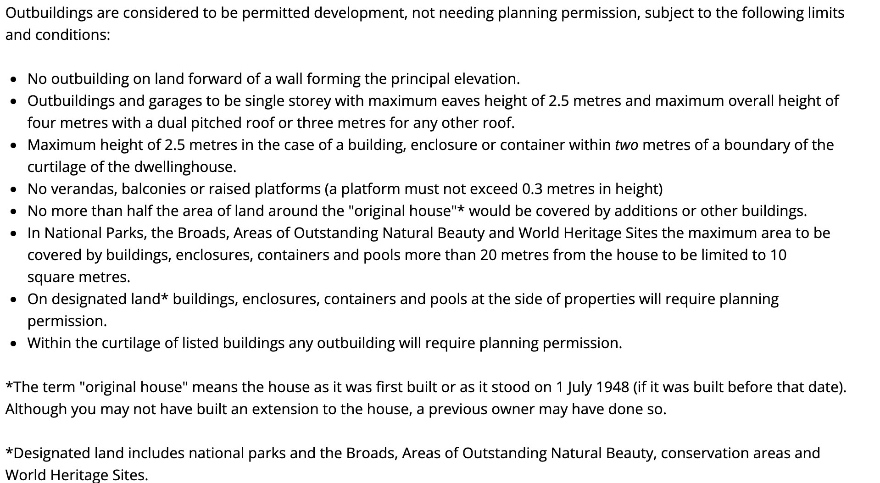

Financial reports for January 2022 meeting
Cash book
16/01/2022 | CASH BOOK
DATE | PAYEE | CURRENT A/C | CURRENT A/C TOTAL FOR YEAR TO DATE
01/04/2021 |  |  | 4707.56
06/04/2021 | GAPTC | -71.81 | 4635.75
27/04/2021 | SALARY | -155.64 | 4480.11
27/04/2021 | HMRC | -38.80 | 4441.31
27/04/2021 | MICROSOFT | -59.99 | 4381.32
16/04/2021 | PRECEPT | 4000.00 | 8381.32
01/06/2021 | RUDFORD VILLAGE HALL | -13.50 | 8367.82
01/06/2021 | CAME AND CO | -358.19 | 8009.63
01/06/2021 | EXPENSES | -64.80 | 7944.83
01/06/2021 | SALARY | -155.64 | 7789.19
08/06/2021 | hmrc | -38.80 | 7750.39
08/06/2021 | pata payroll (20/21) | -95.00 | 7655.39
07/07/2021 | SALARY | -155.44 | 7499.95
02/07/2021 | hmrc | -39.00 | 7460.95
07/07/2021 | RUDFORD VILLAGE HALL | -13.50 | 7447.45
28/07/2021 | HMRC | -43.20 | 7404.25
28/07/2021 | SALARY | -172.72 | 7231.53
28/07/2021 | expenses | -63.40 | 7168.13
02/08/2021 | SWARCO | -152.03 | 7016.10
27/08/2021 | salary | -159.81 | 6856.29
27/08/2021 | HMRC | -40.00 | 6816.29
27/09/2021 | salary | -197.01 | 6619.28
27/09/2021 | HMRC | -39.80 | 6579.48
27/10/2021 | salary | -185.81 | 6393.67
27/10/2021 | hmrc | -40.00 | 6353.67
27/10/2021 | pata payroll (21/22) | -95.00 | 6258.67
05/10/2021 | RUDFORD VILLAGE HALL | -15.00 | 6243.67
16/11/2021 | I selkirk | -150.00 | 6093.67
20/12/2021 | SALARY | -185.81 | 5907.86
20/12/2021 | HMRC | -40.00 | 5867.86
20/12/2021 | grant from glos highways | 3000.00 | 8867.86
23/11/2021 | SALARY | -185.81 | 8682.05
23/11/2021 | expenses | -36.85 | 8645.20
23/11/2021 | hmrc | -40.00 | 8605.20

Payment list to be approved
January salary/wfh £185.81
Expenses £12.98
HMRC £40 estimated
Burton £5064 estimated

Bank reconciliation

BANK RECONCILATION | OPENING BANK BALANCE | 4707.56
 | EXPENDITURE FOR PERIOD | -102.36
 | INCOME FOR PERIOD | 4000.00
Per cash book | NET EXPENDITURE |  | 3897.64
 | BANK BALANCE | 8605.20
28/12/2021 | BAL PER S/M | 8605.20
balance per cash book |  | 8605.20

Expenditure is showing net of footpath grant- waiting for invoices to come

Budget against actual
BUDGET ANALY+C66+A66:C85 | BUDGET | year to date | BALANCE AVAILABLE TO SPEND
PRECEPT | 4000 | 4000 | 0
GRANT FOR TREES |  | 0 | 0
INCOME | 4000 | 4000 | 0
EXPENSES
salary | 2400 | 1798 | 602
HIRE OF VENUE | 200 | 42 | 158
SUBSCRIPTION TO GAPTC | 80 | 72 | 8
TRAINING | 220 | 0 | 220
INSURANCE | 350 | 358 | -8
USE OF HOME/ mileage and stationery | 330 | 280 | 50
TREES | 115 | 0 | 115
BUS SHELTER footpath | 0 | -3000 | 3000
DONATIONS S137 | 0 | 0 | 0
VAS costs | 142 | 152 | -10
audit fees |  | 150 | -150
Neighbourhood D P |  |  | 0
ADMINISTRATION COSTS | 153 | 250 | -97
PREDICTED SURPLUS | 10 |  | 10
EXPENDITURE TOTAL | 4000 | 102 | 3898

Rudford and Highleadon Parish Council

Draft minutes for the meeting of the above Parish Council
Which took place at 7.30pm on 22 November 2021 at the Village Hall

- Council recorded attended
Parish Councillors Bob Wolfson, Mark Deane, Sten Salisbury, Amanda Bye, Ian Turner, Robert Heigham, County Councillor Philip Robinson, 1 member of the public. District Councillor Phillip Burford did not attend
Apologies were received from District Councillor Brian Lewis
- Council noted the resignation of Councillor Hannah Perry-Gardiner and confirmed arrangements for her replacement have been put in place
- Council invited Declarations of Interest related to items in the agenda. Cllr Heigham on PCC, Cllr Turner on Canal

- Council approved the minutes of the meeting held on 26 October 2021.

- Public Session - 15 minutes at Chairman’s Discretion. No comments at this point
- Council noted actions to reduce risk of flooding and remaining actions (see chart below agenda).
- Sandbags now at Village Hall
- Internal Drainage Board will meet with Chair of Council and possibly riparian owners at beginning of December
- Thanks were given to Highway members of staff
- The benefit of table presentation of information was noted

- Highways issues: bfwd on the agenda for County Councillor Robinson
  - Progress on the path to the bus stops at Highleadon Green – Councillor Wolfson reported. It was confirmed grey dust is to be used and work is due to start on 24th November.
Clarification on receiving funding from GCC was sought via Andrew Middleton and County Councillor Robinson. It was agreed to that the PC will raise an invoice in the sum of £3000
b. Footpath GR14 – Councillors considered making application to the Build Back Better Fund. Cllr Salisbury gave an update including email from Suzanne Hopes (PROW officer) £12,000 for 700 meters is the figure being quoted and a local contractor has been asked for a quotation based on the specification supplied by PROW officer. RFO advised that 3 quotations will be needed, which Cllr Salisbury will seek. County Councillor Robinson was asked if there would be any funding available from other sources, such as Highways joint funding, Build Back Better and some from Parish Council. County Councillor Robinson suggested that it may be possible to support if applications are made.
It was agreed Cllr Wolfson to contact JBM Solar project as a possible idea for a Community funded project.
  - Water leak in Church Lane – Councillor Wolfson reported

- County Councillor Robinson verbally reported on
- the Nuclear Fusion Plant (Oldbury and Berkeley are now short listed) and if successful, the plant would generate 10,000’s of jobs in Gloucestershire in the medium-term including apprenticeships. It is a “clean” production of energy.
- Questions were asked on housing requirements of expanding work-force
- Police and Crime Commissioner’s road-show likely to be scheduled in January 2022 at Hartpury Village Hall with specific focus on Parishes locally near to Rudford and Highleadon.
- Feedback from the recent Crime Commissioner’s road-show held near Tewkesbury was given by Cllr Wolfson. Cllr Wolfson reinforced the frustration and anti-social behaviour that is generated by the lack of Enforcement on planning matters

- Planning matters were discussed
- Enforcement issues at New Bliss Business Centre feedback from Cllr Wolfson
Member of public gave an update
- Enforcement issues P0165 at Rectory Fields, Church Lane feedback from Cllr Wolfson
- P0939 – Laynes Farm – conversion of barn: application withdrawn
- Pending consideration at this time: P0162 – Shooting Ground in Hartpury Parish
- Land for sale at Dark Barn was noted. Councillors discussed the historic planning conditions associated with the access point off the B4165
- JBM Solar's proposals for Laynes Wood Solar Farm- update as emailed (waiting for formal planning application to be submitted). Concerns over traffic during construction period were raised. Council agreed to discuss fully when application is submitted.
- Questioned if planning application has been received for construction of summer house – 4 winds Upleadon Road- does not appear to be on portal
- Forest of Dean District Council Development Plan: Councillor Wolfson reported on the first meeting of the Community Forum and most recent Cross-Parish group

- Correspondence received noted (as distributed by email to Councillors)
a. https://www.local.gov.uk/our-support/guidance-and-resources/civility-public-life
b. Standards Complaints Reminder of Role of MO

- Financial reports: Council approved the financial reports and payments list as attached
- Council approved the precept/budget for 2022/23 in the sum of £4200 (as attached)
- Council considered a request for a grant towards the maintenance of the Church yard. (RFO has distributed NALC LO1-18 financial assistance to the Church and it was noted that there is no provision in current year’s budget for donations or grants).
Councillor Bye asked for the current policy of the Council relating to grants and donations
Councillor Wolfson asked for explanations on points in the submitted financial statements eg charity donations, 200 Club income, income from burials and potential of income from those who are buried there.
Cllr Heigham spoke on behalf of PCC (having declared an interest)
It was proposed and seconded that the Council follow the advice of NALC and do not support a request for funding. A vote was taken and 4 agreed with the proposal and 1 against. There-fore the request for funding was declined. It was agreed that Cllr Wolfson will offer a meeting with the Church wardens to discuss this matter in more detail.
- Council noted independent audit is completed with no issues raised
- Council invited District Councillor reports – none attended
- Date of next meeting: 24 January 2022 at 7.30pm in the Village Hall
- Minor Items Raised by Members for Future Agenda:
Road sign with curve has been installed and Glos Highways have been informed that it does not suit the purpose and they informed Parish Councillors could put its own sign up. Cllr Wolfson will speak to Glos Highways managers.

Meeting closed at 21.00pm

